**Intel-i9-7980XE Processor**

**MICROPROCESSOR**

**T. E. Computer Engineering**

Under the guidance of

**Ms. Pratibha Rane**

By

**Darrel Noronha 03**

**Harsh Oza 04**

**Shelton Pinto 12**



Department of Computer Engineering

St. Francis Institute of Technology

University of Mumbai

2019-2020

**HISTORY:**

The following is a list of [Intel Core](https://en.wikipedia.org/wiki/Intel_Core) i9 brand [microprocessors](https://en.wikipedia.org/wiki/Microprocessor). They were introduced in May 2017.With their high number of cores, high power draw, high thermal output, and high performance, they are intended to be used by enthusiasts. A mobile version based on the standard BGA1440 socket was released in 2018, featuring six [hyperthreaded](https://en.wikipedia.org/wiki/Hyper-threading) cores and 12 MB of cache. It has been proven to be able to attain 5 gigahertz under ideal conditions.

|  |  |  |  |  |
| --- | --- | --- | --- | --- |
| **Model**  **number** | **sSpec**  **number** | **Cores**  **(threads)** | **Frequency** | [**Turbo Boost**](https://en.wikipedia.org/wiki/Intel_Turbo_Boost)  **all-core/2.0**  **(/max. 3.0)** |
| [Core i9-7900X](http://ark.intel.com/products/123613) | SR3L2 (U0) | 10 (20) | 3.3 GHz | 4.0/4.3 GHz  4.5 GHz |
| [Core i9-7920X](http://ark.intel.com/products/126240) | SR3NG (U0) | 12 (24) | 2.9 GHz | 3.8/4.3 GHz  4.4 GHz |
| [Core i9-7940X](http://ark.intel.com/products/126695) | SR3RQ (U0) | 14 (28) | 3.1 GHz | 3.8/4.3 GHz  4.4 GHz |
| [Core i9-7960X](http://ark.intel.com/products/126697) | SR3RR (U0) | 16 (32) | 2.8 GHz | 3.6/4.2 GHz  4.4 GHz |
| [Core i9-7980XE](http://ark.intel.com/products/126699) | SR3RS (U0) | 18 (36) | 2.6 GHz | 3.4/4.2 GHz  4.4 GHz |
| [Core i9-9820X](http://ark.intel.com/products/189121) | SREZ8 (M0) | 10 (20) | 3.3 GHz | 4.0/4.1 GHz  4.2 GHz |
| [Core i9-9900X](http://ark.intel.com/products/189124) | SREZ7 (M0) | 10 (20) | 3.5 GHz | 4.1/4.4 GHz  4.5 GHz |
| [Core i9-9920X](http://ark.intel.com/products/189127) | SREZ6 (M0) | 12 (24) | 3.5 GHz | 4.2/4.4 GHz  4.5 GHz |
| [Core i9-9940X](http://ark.intel.com/products/189125) | SREZ5 (M0) | 14 (28) | 3.3 GHz | 4.1/4.4 GHz  4.5 GHz |
| [Core i9-9960X](http://ark.intel.com/products/189123) | SREZ4 (M0) | 16 (32) | 3.1 GHz | 4.0/4.4 GHz  4.5 GHz |
| [Core i9-9980XE](http://ark.intel.com/products/189126) | SREZ3 (M0) | 18 (36) | 3 GHz | 3.8/4.4 GHz  4.5 GHz |
| Core i9-9990XE | SREZA (M0) | 14 (28) | 4 GHz | 5.0/5.0 GHz  5.1 GHz |

Following are the information for memory and release date information with their prices for all Intel-i9 model.

|  |  |  |  |
| --- | --- | --- | --- |
| **Model**  **number** | [**Memory**](https://en.wikipedia.org/wiki/Memory_controller) | **Release date** | **Release**  **price (**[**USD**](https://en.wikipedia.org/wiki/United_States_dollar)**)** |
| [Core i9-7900X](http://ark.intel.com/products/123613) | 4 × DDR4-2666 | June 2017 | $989 |
| [Core i9-7920X](http://ark.intel.com/products/126240) | 4 × DDR4-2666 | August 2017 | $1199 |
| [Core i9-7940X](http://ark.intel.com/products/126695) | 4 × DDR4-2666 | September 2017 | $1399 |
| [Core i9-7960X](http://ark.intel.com/products/126697) | 4 × DDR4-2666 | September 2017 | $1699 |
| [Core i9-7980XE](http://ark.intel.com/products/126699) | 4 × DDR4-2666 | September 2017 | $1999 |
| [Core i9-9820X](http://ark.intel.com/products/189121) | 4 × DDR4-2666 | Q4 2018 | $889 |
| [Core i9-9900X](http://ark.intel.com/products/189124) | 4 × DDR4-2666 | Q4 2018 | $989 |
| [Core i9-9920X](http://ark.intel.com/products/189127) | 4 × DDR4-2666 | Q4 2018 | $1189 |
| [Core i9-9940X](http://ark.intel.com/products/189125) | 4 × DDR4-2666 | Q4 2018 | $1387 |
| [Core i9-9960X](http://ark.intel.com/products/189123) | 4 × DDR4-2666 | Q4 2018 | $1684 |
| [Core i9-9980XE](http://ark.intel.com/products/189126) | 4 × DDR4-2666 | Q4 2018 | $1979 |
| Core i9-9990XE | 4 × DDR4-2666 | 2019 | auctions  for OEMs |

**i9-7980XE:**

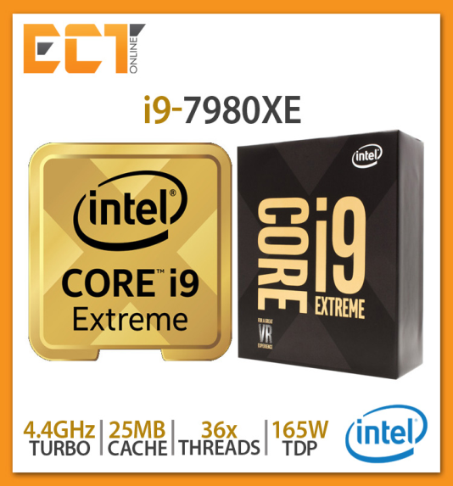

**Figure 1 - Intel i9-7980XE**

Intel i9-7980XE Extreme Edition processor was released in September 2017 and priced $1999.It had 24.75M cache and clock speed upto 4.4 GHz and base frequency 2.6 Ghz. Its memory type is 4 × DDR4-2666. It has 18 Cores and 36 threads.the architecture is given below.This processor was released with i9-7940X and i9-7960X

**ARCHITECTURE:**

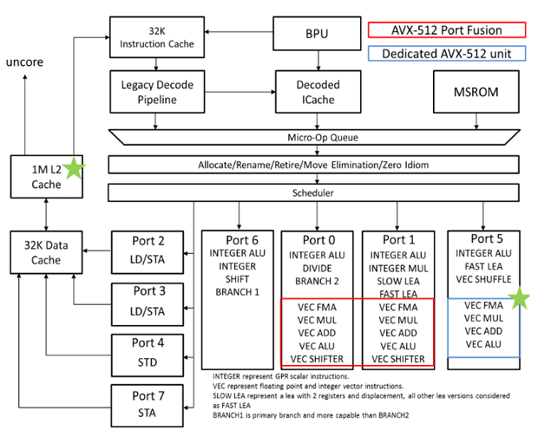

**Figure 2 - Block Diagram of i9-7890XE**

i9-7980XE is based on the Skylake and Kaby Lake architectures with all of them utilizing the new LGA 2066 socket, making compatibility across the X-series very simple. It has core count ranging from 4 to 18, which translates to 36 threads and supports quad channel memory and the new Turbo Boost Max 3.0 technology on more than four cores. It has channels of DDR4 2666 and 44 lanes of PCIe 3.0 and Intel Optane memory as well as up to eight SATA 3.0 ports, 10 USB 3.0 ports and up to three PCIe 3.0 x4 drives. It has 3 cache memory L1 , L2, L3. It is 14nm chip. It uses CMOS technology. It has 64-bit word size.

**MEMORY ORGANIZATION:**

The maximum memory size i.e. maximum memory supported by Intel i9 is 128 GB. Intel processors come in four different types: a Single Channel, Dual Channel, Triple Channel, and Flex Mode. DDR4-2666 is the memory type. The maximum number of memory channels is 4. Error Correcting Code Memory is not supported. The processor also features 24.75 MB of Smart Cache, support for up to 44 PCIe 3.0 lanes, quad channel memory, and a 165W TDP. The maximum bandwidth is 79.47 GiB. The cache organization is categorized into L1 1.125 MiB, L2 18 MiB and L3 24.75 MiB. Out of which L1 is 8 way set associative. L2 is 16 way associative and L3 is 11 way associative.

**ADVANTAGES:**

* The Intel i9-7980XE packs more processing cores than the i9-7900X microprocessor.
* Large number of cores helps this CPU to handle many processes or threads at once.
* More cores for better multi-threading performance.
* Can execute more threads at once.

**DISADVANTAGES:**

* It runs at lower frequency.
* Terrible value compared to AMD Threadripper chips.
* It is very costly processor at $1999.
* It requires powerful CPU coolers.

**CONCLUSION:**

This Case Study on Intel i9-7980XE explained to us about the features of this processor.This chip, which is based on the [Skylake](https://en.wikichip.org/wiki/intel/microarchitectures/skylake) microarchitecture, is fabricated on Intel's enhanced [14nm+ process](https://en.wikichip.org/wiki/14_nm_process). We also learnt about all models of Intel i9 and their features.We saw the architecture of i9-7980XE, we understood its maximum clock speed is 4.4 Ghz.We saw its memory organization and cache organization where it has cache 24.75MiB. It has L1, L2 and L3 Cache. We can conclude that the Core i9-7980XE succeeds the [Core i7-6950X](https://en.wikichip.org/wiki/intel/core_i7-6950x) as Intel's flagship microprocessor based on [Skylake](https://en.wikichip.org/wiki/intel/microarchitectures/skylake) microarchitecture - also becoming the first consumer-class [octadeca-core](https://en.wikichip.org/wiki/octadeca-core) microprocessor.

**REFERENCES:**

<https://www.intel.com/content/dam/www/public/us/en/documents/datasheets/6th-gen-x-series-datasheet-vol-1.pdf>

<https://ark.intel.com/content/www/us/en/ark/products/126699/intel-core-i9-7980xe-extreme-edition-processor-24-75m-cache-up-to-4-20-ghz.html>

<https://en.wikichip.org/wiki/intel/core_i9/i9-7980xe>

<http://www.cpu-world.com/CPUs/Core_i9/Intel-Core%20i9%20Extreme%20Edition%20i9-7980XE.html>